Project Design Phase-II
Solution Requirements (Functional & Non-functional)

Date | 07/03/2026
Team ID | SWTID-2026-1013
Project Name | MicroGoal
Maximum Marks | 4 Marks

Functional Requirements:
Following are the functional requirements of the proposed solution.

FR No. | Functional Requirement (Epic) | Sub Requirement (Story / Sub-Task)
FR-1 | User Authentication & Account Management | User Registration
 |  | User Login
 |  | Password Encryption (Hashing)
 |  | JWT Token Generation
FR-2 | Goal Management (CRUD Operations) | Create Goal
 |  | View All Goals (User-Specific)
 |  | Update Goal
 |  | Delete Goal
FR-3 | Authorization & Access Control | Protect Routes using Auth Middleware
 |  | Restrict Users from Accessing Others' Data
FR-4 | Error Handling & Response Management | Centralized Error Middleware
 |  | Proper HTTP Status Codes (200, 201, 400, 401, 404, 500)
FR-5 | API Testing & Validation | Test Endpoints using Thunder Client
 |  | Validate Request Body Data

Non-functional Requirements:
Following are the non-functional requirements of the proposed solution.

NFR No. | Non-Functional Requirement | Description
NFR-1 | Usability | API endpoints should be simple, clear, and easy to understand for developers.
NFR-2 | Security | All API requests must be secured using JWT authentication. Passwords must be hashed before storing.
NFR-3 | Reliability | The system should handle errors properly and avoid crashes during invalid requests.
NFR-4 | Performance | API responses should be returned within 2 seconds under normal load conditions.
NFR-5 | Availability | The backend server should be accessible 24/7 with minimal downtime.
NFR-6 | Scalability | The system should support increasing users and goals without performance degradation. The architecture should allow future feature expansion.

Project Design Phase-II
Technology Stack (Architecture & Stack)

Date | 07/03/ 2026
Team ID | SWTID-2026-1013
Project Name | MicroGoal
Maximum Marks | 4 Marks

Technical Architecture:-
Table 1:-

S.No | Component | Description | Technology
1 | User Interface | API testing interface for sending requests | Thunder Client
2 | Application Logic-1 | User authentication and account management | Node.js + Express.js
3 | Application Logic-2 | Goal CRUD operations and data processing | Node.js + Express.js
4 | Authentication Layer | Token generation and verification | JSON Web Token (JWT)
5 | Database Layer | Store users and goals data | MongoDB + Mongoose
6 | Middleware Layer | Route protection and centralized error handling | Express Middleware

Table 2:-

S.No | Characteristics | Description | Technology
1 | Open-Source Frameworks | Backend development framework | Node.js, Express.js
2 | Database | NoSQL database for storing structured data | MongoDB
3 | Security | Secure API access using token-based authentication | JWT
4 | API Communication | RESTful API using HTTP methods (GET, POST, PUT, DELETE) | Express.js
5 | Scalable Architecture | Modular MVC structure for future expansion | MVC Pattern
6 | API Testing | Endpoint validation and debugging | Thunder Client

Project Design Phase-II
Data Flow Diagram & User Stories

Date | 07/03/2026
Team ID | SWTID-2026-1013
Project Name | MicroGoal
Maximum Marks | 4 Marks

Data Flow Diagrams:
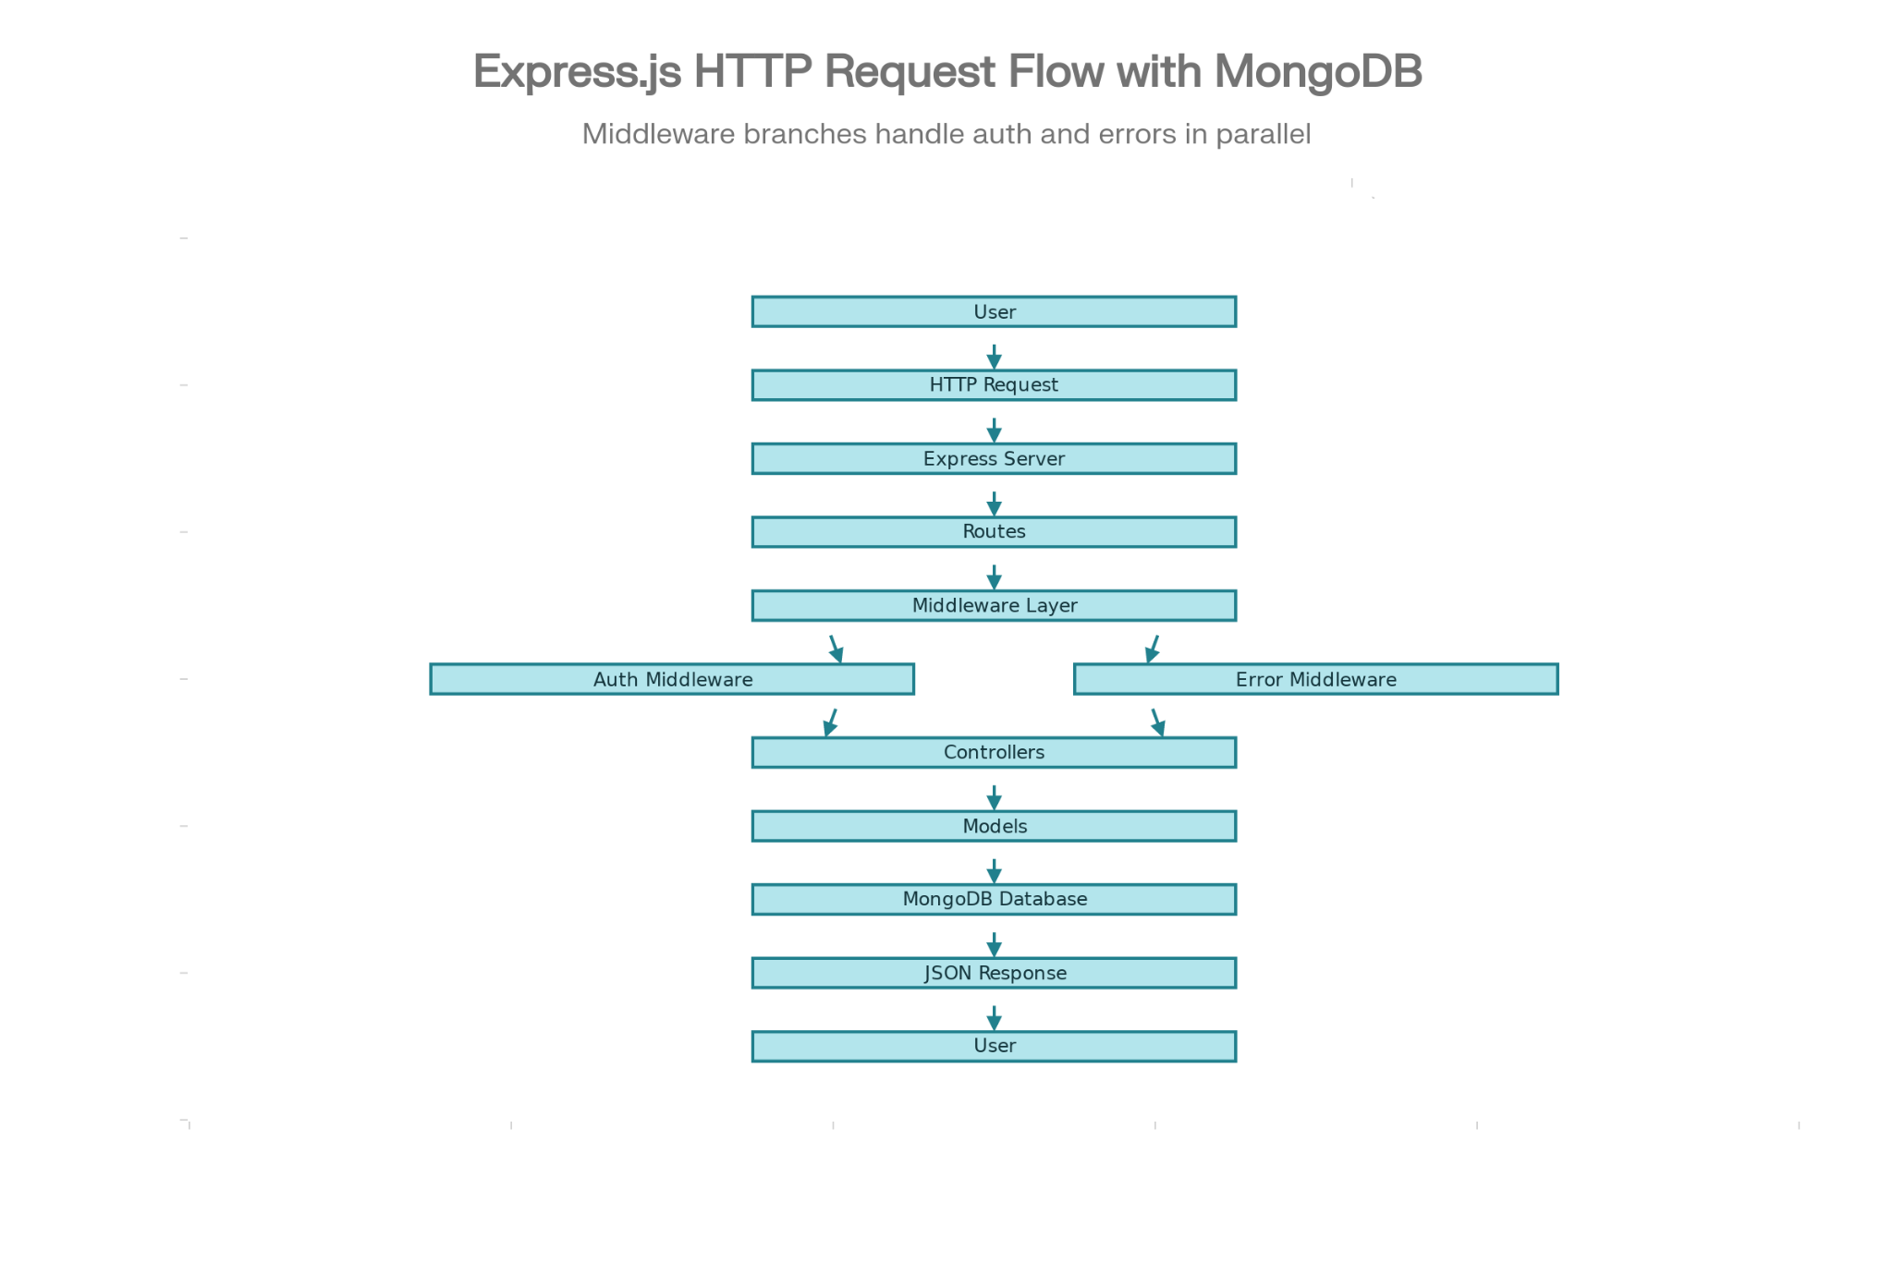User Stories – MicroGoals Backend API:-

User Type | User Story Number | User Story / Task | Acceptance Criteria | Priority | Release
Customer (Web User) | USN-1 | As a user, I want to register an account so that I can access the system. | The user data is stored in the database and a success response is returned. | High | Sprint-1
Customer (Web User) | USN-2 | As a user, I want to log in securely so that I can access my personal goals. | A valid email and password generate a JWT token and return status 200. | High | Sprint-1
Customer (Web User) | USN-3 | As a user, I want to create a new goal so that I can manage my tasks. | The goal is saved in the database and a 201 status code is returned. | High | Sprint-1
Customer (Web User) | USN-4 | As a user, I want to view my goals so that I can track my progress. | Only authenticated users can access their own goals. | High | Sprint-1
Customer (Web User) | USN-5 | As a user, I want to update my existing goal so that I can modify my tasks. | The updated goal reflects correctly in the database. | High | Sprint-1
Customer (Web User) | USN-6 | As a user, I want to delete a goal so that I can remove completed or unnecessary tasks. | The goal is permanently deleted and a success response is returned. | High | Sprint-1
Customer (Web User) | USN-7 | As a user, I want my data to be protected so that other users cannot access my goals. | Unauthorized access returns a 401 Unauthorized error. | High | Sprint-1

Developer / Admin | USN-8 | As a developer, I want to test API endpoints to ensure they work correctly. | All endpoints return correct responses and status codes in Thunder Client. | Medium | Sprint-2
Developer | USN-9 | As a developer, I want centralized error handling so that errors are managed efficiently. | Errors are handled through middleware and proper messages are returned. | Medium | Sprint-2

